Trustees
RECRUITMENT INFORMATION PACK
Ramps on the Moon

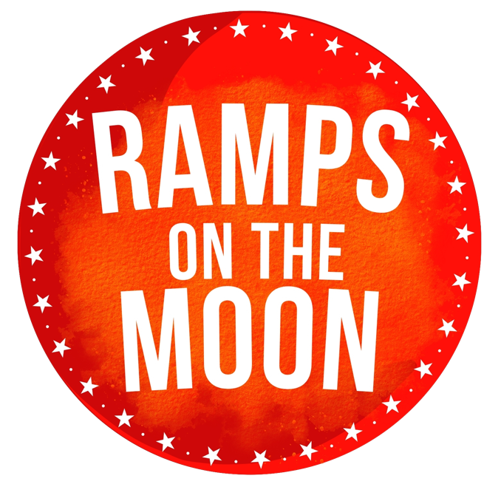

Ramps on the Moon is seeking new Trustees to guide us in our strategic consolidation and development. Our Board is key in helping us to deliver our mission.

About Ramps on the Moon
We exist to enrich the stories we tell in the cultural industries, and the ways we tell them, by elevating the place of disabled people in the mainstream.
Our vision is a mainstream cultural sector free of ableism, in which disabled people can develop ambition, gain skills, work, innovate, fail, learn, thrive and flourish, making impact in the cultural landscape of the UK and beyond.
Ramps began its life in 2015 following a successful tour of The Threepenny Opera, a co-production between Graeae Theatre, The New Wolsey in Ipswich, Leeds (then West Yorkshire) Playhouse, Nottingham Playhouse and Birmingham REP. Ramps was funded by Arts Council England for 8 years and operated as a consortium of 6 mid-scale mainstream producing theatres.
Ramps became known for large scale mainstage productions such as The Who’s Tommy (2016, New Wolsey Theatre) and Much Ado About Nothing (2022, Sheffield Theatres), but there was also a lot of work going on offstage to remove the barriers experienced by disabled people to the mainstream cultural sector.
Mainstreaming the Social Model of Disability is core. Ramps is anchored in the Social Model, advocating for it and demonstrating its efficacy through the work that partners have made.
Consortium partners have reported some key benefits of their work with Ramps on the Moon:
- Greater confidence in implementing disability equality
- Greater confidence and transparency in talking about disability equality
- Widening the pool of skills and talent they can tap into
- Elevating the quality of the work they make
- Audience development
The impact of Ramps has reached into the wider industry and beyond: eg we have contributed to panels for companies working in opera, ballet and dance, visual arts and cinema. We have worked with the Royal Opera House and HQ Theatres. We have also had international impact, eg in Finland and Germany, and we had key presence at the Luminous Festival in China in 2020 and the 2023 No Limits Festival in Hong Kong.
In 2023 Ramps was awarded funding by the Esmée Fairbairn Foundation to
Whilst we still retain the original vision and mission, we need to push further in order to achieve the change we are seeking. We are working to shift the conversation in the sector from ‘access’, or even ‘disability equality’ to anti-ableism and we are delivering a series of workshops to a cohort of organisations to enable them to embed anti-ableism.
Alongside the cohort activity, we remain responsive to the needs of the sector and deliver training and consultancy to effect systemic change.
You can find out more at https://rampsonthemoon.co.uk

Role Description – Member of the Board of Trustees
Responsible to | Chair of Trustees
Responsible for | Supporting Ramps on the Moon to realise its mission, advocating for Ramps on the Moon
Start date | Spring 2025
Term | Three years, potentially renewable for a second term of three years subject to review.
Location | Sheffield, subject to Board agreement
Time commitment | Around 15 days per year, including four Board Meetings per year, subcommittee meetings as required, and a yearly away-day.  Trustees will also be invited to attend Ramps events and may be asked to represent Ramps on the Moon at certain events.
Remuneration | The role of Trustee is not accompanied by any financial remuneration, although travel and access expenses may be claimed, in line with guidance provided by the Charity Commission.

Responsibilities
The Trustees will guide the strategic development of Ramps on the Moon. This breaks down across the following areas:
Strategy and planning
- Work closely with the Director for Change to devise appropriate plans and that effective recording, monitoring and oversight of the implementation of those plans are in place.
- Scrutinise budgets and ensure financial resilience.
- Regularly review major risks and associated opportunities and satisfies itself that Ramps is in a place to take advantage of opportunities and manage and mitigate the risks.
- Sensibly encourage positive change and risk-taking where appropriate.
- Provide leadership and support through committing the required time to the role and being accessible and available to Ramps if there are periods of crisis.
Being an Effective Member of the Board
- Fulfil their responsibilities for Ramps’ overall governance and strategic development.
- Participate in skills audits and engage with other established or emerging good practices under the guidance of the Chair of the Board.
- Contribute to an inclusive, cohesive, and collaborative board culture ensuring clarity of purpose and accountability. Contribute their individual skills, experience and industry contacts.
Board meetings
- Attend Board meetings where possible and at least 3 times a year.
- Contribute to appropriate sub-committees.
- Ensure that professional standards are maintained within all Board meetings and processes.

Governance
- Work with the Chair, other Trustees and the Director for Change to further the growth and successful achievement of Ramps’ objectives.
- Commit to fulfilling their responsibilities for the governance of Ramps on the Moon.
Advocacy
- Advocate for Ramps on the Moon externally, building the profile of its brand and helping to establish and strengthen opportunities.
- Make the most of relevant professional and/or personal networks across the sector, to advance the interests of Ramps on the Moon.
- Represent Ramps at key events. Act as a spokesperson for Ramps when appropriate.
In addition, we expect Trustees to adhere to the seven principles of public life as defined by the Nolan Committee. These are selflessness, integrity, objectivity, accountability, openness, honesty and leadership.
These tasks are indicative only and not exhaustive. Board members will be expected to perform reasonable additional duties.

What will you get in return?
Ramps on the Moon commits to
- Meeting your access requirements, including your travel requirements
- Providing an induction to Ramps on the Moon
- Letting you know what we are doing and where appropriate to invite you to events so that you are able to connect fully with our work and advocate for Ramps on the Moon and our vision to change the cultural sector
- Remaining open to your feedback and suggestions.

Person Specification
Ramps on the Moon Board members will be passionate about Ramps’ mission and passionate and knowledgeable about the landscape in which we operate.
- Commitment to Ramps’ mission and values and a willingness to devote time to carry out the responsibilities of the role.
- Awareness of and commitment to high principles and standards of professional practice, always considering Ramps’ reputation.
- Experience of working (in any capacity) and building relationships in the arts sector.
- Integrity and an ability to exercise fair judgement.
- Ability to think creatively in the context of Ramps on the Moon, its client base, and the arts sector.
- Confidence and willingness to represent Ramps at events, workshops, and meetings in an ambassadorial capacity.
- Previous experience as a Trustee.
- Connections to networks that may be advantageous to Ramps on the Moon.
How to apply
Please send a letter or video outlining your relevant experience and suitability for the role to Michèle Taylor, Director for Change, at
michele@rampsonthemoon.co.uk

